13.60: This distance 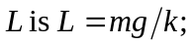 the period of the oscillatory motion is
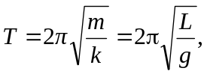
which is the period of oscillation of a simple pendulum of lentgh L.

